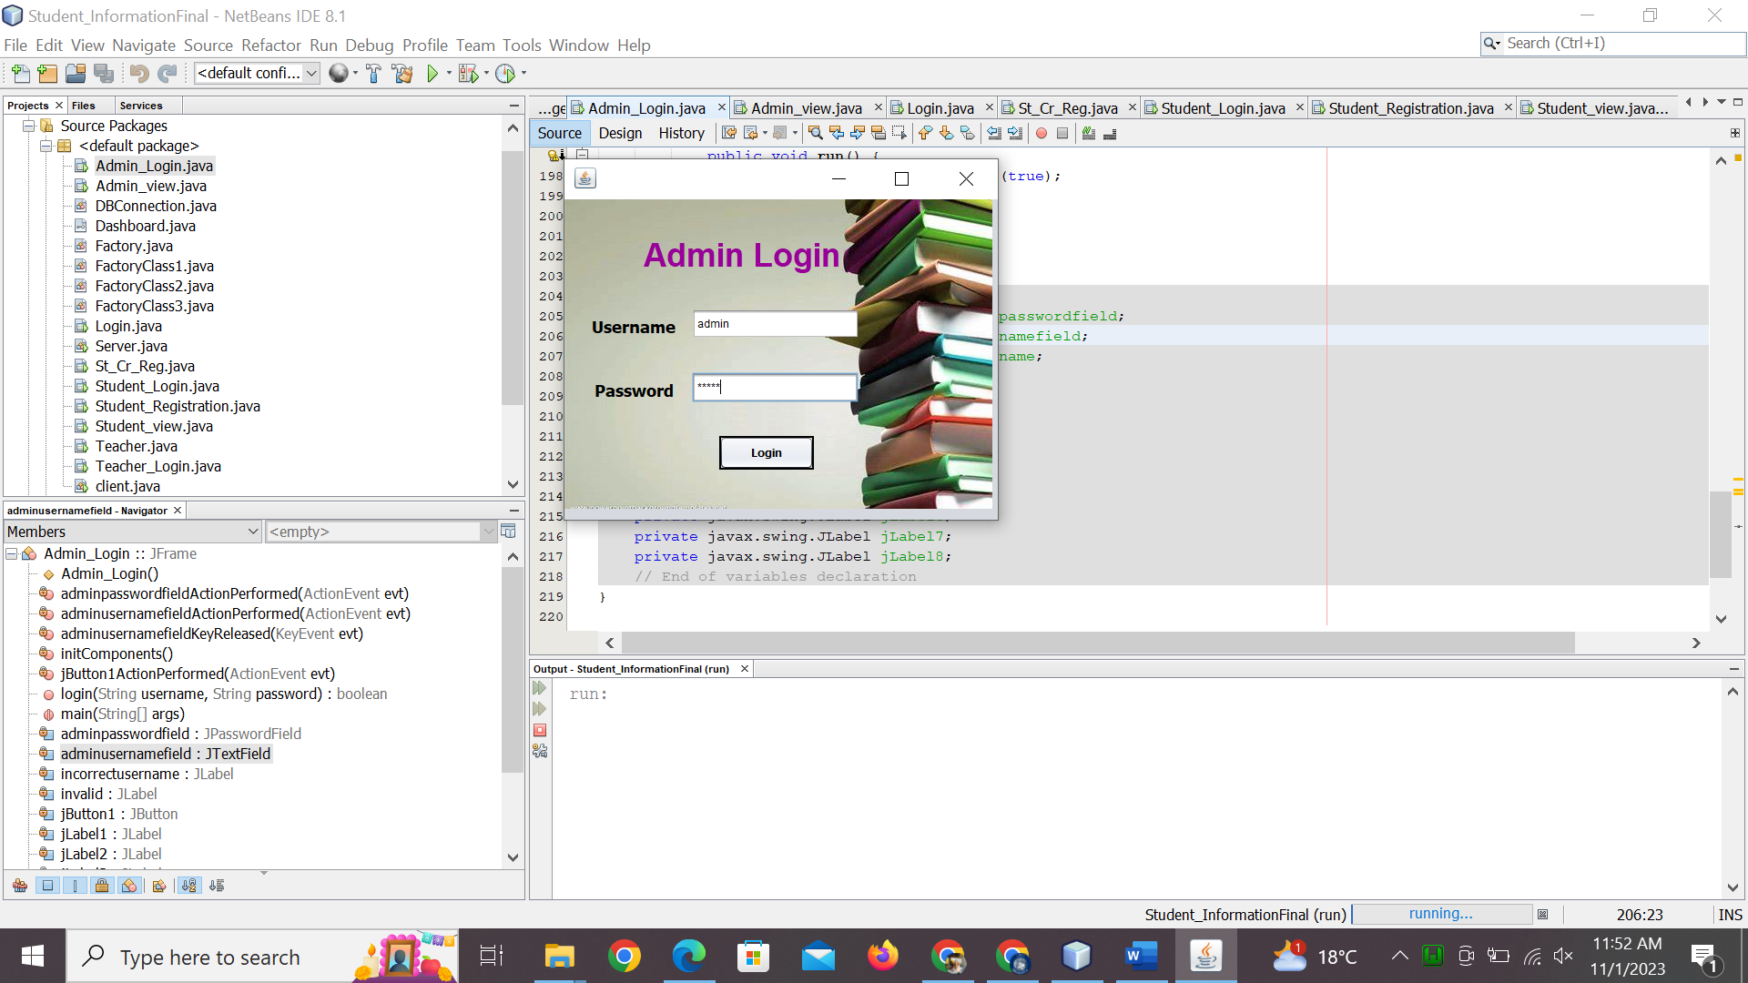

import java.util.regex.Matcher;

import java.util.regex.Pattern;

/*

* To change this license header, choose License Headers in Project Properties.

* To change this template file, choose Tools | Templates

* and open the template in the editor.

*/

/**

*

* @author

*/

public class Admin_Login extends javax.swing.JFrame {

/**

* Creates new form Admin_Login

*/

public Admin_Login() {

initComponents();

}

/**

* This method is called from within the constructor to initialize the form.

* WARNING: Do NOT modify this code. The content of this method is always

* regenerated by the Form Editor.

*/

@SuppressWarnings("unchecked")

// <editor-fold defaultstate="collapsed" desc="Generated Code">

private void initComponents() {

jLabel5 = new javax.swing.JLabel();

jLabel6 = new javax.swing.JLabel();

jLabel1 = new javax.swing.JLabel();

jLabel2 = new javax.swing.JLabel();

adminusernamefield = new javax.swing.JTextField();

jLabel3 = new javax.swing.JLabel();

jButton1 = new javax.swing.JButton();

adminpasswordfield = new javax.swing.JPasswordField();

invalid = new javax.swing.JLabel();

jLabel4 = new javax.swing.JLabel();

incorrectusername = new javax.swing.JLabel();

jLabel7 = new javax.swing.JLabel();

jLabel8 = new javax.swing.JLabel();

jLabel5.setText("jLabel5");

jLabel6.setText("jLabel6");

setDefaultCloseOperation(javax.swing.WindowConstants.EXIT_ON_CLOSE);

getContentPane().setLayout(new org.netbeans.lib.awtextra.AbsoluteLayout());

jLabel1.setFont(new java.awt.Font("Arial", 1, 36)); // NOI18N

jLabel1.setForeground(new java.awt.Color(153, 0, 153));

jLabel1.setHorizontalAlignment(javax.swing.SwingConstants.CENTER);

jLabel1.setText("Admin Login");

jLabel1.setCursor(new java.awt.Cursor(java.awt.Cursor.DEFAULT_CURSOR));

getContentPane().add(jLabel1, new org.netbeans.lib.awtextra.AbsoluteConstraints(80, 40, 230, -1));

jLabel2.setFont(new java.awt.Font("Tahoma", 1, 18)); // NOI18N

jLabel2.setHorizontalAlignment(javax.swing.SwingConstants.CENTER);

jLabel2.setText("Password");

getContentPane().add(jLabel2, new org.netbeans.lib.awtextra.AbsoluteConstraints(30, 200, 92, 20));

adminusernamefield.addActionListener(new java.awt.event.ActionListener() {

public void actionPerformed(java.awt.event.ActionEvent evt) {

adminusernamefieldActionPerformed(evt);

}

});

adminusernamefield.addKeyListener(new java.awt.event.KeyAdapter() {

public void keyReleased(java.awt.event.KeyEvent evt) {

adminusernamefieldKeyReleased(evt);

}

});

getContentPane().add(adminusernamefield, new org.netbeans.lib.awtextra.AbsoluteConstraints(140, 120, 184, 33));

jLabel3.setFont(new java.awt.Font("Tahoma", 1, 18)); // NOI18N

jLabel3.setHorizontalAlignment(javax.swing.SwingConstants.CENTER);

jLabel3.setText("Username");

getContentPane().add(jLabel3, new org.netbeans.lib.awtextra.AbsoluteConstraints(30, 130, -1, 20));

jButton1.setFont(new java.awt.Font("Tahoma", 1, 12)); // NOI18N

jButton1.setText("Login");

jButton1.setBorder(javax.swing.BorderFactory.createMatteBorder(2, 2, 2, 2, new java.awt.Color(0, 0, 0)));

jButton1.addActionListener(new java.awt.event.ActionListener() {

public void actionPerformed(java.awt.event.ActionEvent evt) {

jButton1ActionPerformed(evt);

}

});

getContentPane().add(jButton1, new org.netbeans.lib.awtextra.AbsoluteConstraints(170, 260, 104, 37));

adminpasswordfield.addActionListener(new java.awt.event.ActionListener() {

public void actionPerformed(java.awt.event.ActionEvent evt) {

adminpasswordfieldActionPerformed(evt);

}

});

getContentPane().add(adminpasswordfield, new org.netbeans.lib.awtextra.AbsoluteConstraints(140, 190, 183, 33));

getContentPane().add(invalid, new org.netbeans.lib.awtextra.AbsoluteConstraints(186, 329, 183, 23));

jLabel4.setFont(new java.awt.Font("Tahoma", 3, 14)); // NOI18N

jLabel4.setForeground(new java.awt.Color(204, 0, 0));

getContentPane().add(jLabel4, new org.netbeans.lib.awtextra.AbsoluteConstraints(262, 203, 159, -1));

incorrectusername.setFont(new java.awt.Font("Tahoma", 3, 12)); // NOI18N

incorrectusername.setForeground(new java.awt.Color(204, 0, 0));

incorrectusername.setHorizontalAlignment(javax.swing.SwingConstants.CENTER);

incorrectusername.setAutoscrolls(true);

getContentPane().add(incorrectusername, new org.netbeans.lib.awtextra.AbsoluteConstraints(140, 160, 180, 18));

getContentPane().add(jLabel7, new org.netbeans.lib.awtextra.AbsoluteConstraints(0, 0, -1, 340));

jLabel8.setIcon(new javax.swing.ImageIcon("C:\\Users\\USER\\Desktop\\pix\\a.jpeg")); // NOI18N

jLabel8.setText("jLabel8");

getContentPane().add(jLabel8, new org.netbeans.lib.awtextra.AbsoluteConstraints(0, 0, 470, 340));

pack();

}// </editor-fold>

private void adminusernamefieldActionPerformed(java.awt.event.ActionEvent evt) {

// TODO add your handling code here:

}

private void jButton1ActionPerformed(java.awt.event.ActionEvent evt) {

// TODO add your handling code here:

login( adminusernamefield.getText(), adminpasswordfield.getText());

}

public boolean login(String username , String password){

try{

invalid.setText("-"+username+"-"+password+"-");

if (username.equals("admin") && password.equals("admin"))

{

Admin_view adminview= new Admin_view();

adminview.setVisible(true);

setVisible(false);

dispose();

return true;

}

else {

invalid.setText("Invalid Username And Password");

return false;

}

}

catch(Exception e){

System.out.println("Exception "+e);

return false;

}

}

private void adminpasswordfieldActionPerformed(java.awt.event.ActionEvent evt) {

// TODO add your handling code here:

}

private void adminusernamefieldKeyReleased(java.awt.event.KeyEvent evt) {

// TODO add your handling code here:

// TODO add your handling code here:

String PATTERN="^[a-zA-Z]{0,10}$";

Pattern patt=Pattern.compile(PATTERN);

Matcher match=patt.matcher(adminusernamefield.getText());

if(!match.matches()){

incorrectusername.setText("username is incorrect!");

}

else{

incorrectusername.setText(null);

}

}

/**

* @param args the command line arguments

*/

public static void main(String args[]) {

/* Set the Nimbus look and feel */

//<editor-fold defaultstate="collapsed" desc=" Look and feel setting code (optional) ">

/* If Nimbus (introduced in Java SE 6) is not available, stay with the default look and feel.

* For details see http://download.oracle.com/javase/tutorial/uiswing/lookandfeel/plaf.html

*/

try {

for (javax.swing.UIManager.LookAndFeelInfo info : javax.swing.UIManager.getInstalledLookAndFeels()) {

if ("Nimbus".equals(info.getName())) {

javax.swing.UIManager.setLookAndFeel(info.getClassName());

break;

}

}

} catch (ClassNotFoundException ex) {

java.util.logging.Logger.getLogger(Admin_Login.class.getName()).log(java.util.logging.Level.SEVERE, null, ex);

} catch (InstantiationException ex) {

java.util.logging.Logger.getLogger(Admin_Login.class.getName()).log(java.util.logging.Level.SEVERE, null, ex);

} catch (IllegalAccessException ex) {

java.util.logging.Logger.getLogger(Admin_Login.class.getName()).log(java.util.logging.Level.SEVERE, null, ex);

} catch (javax.swing.UnsupportedLookAndFeelException ex) {

java.util.logging.Logger.getLogger(Admin_Login.class.getName()).log(java.util.logging.Level.SEVERE, null, ex);

}

//</editor-fold>

/* Create and display the form */

java.awt.EventQueue.invokeLater(new Runnable() {

public void run() {

new Admin_Login().setVisible(true);

}

});

}

// Variables declaration - do not modify

private javax.swing.JPasswordField adminpasswordfield;

private javax.swing.JTextField adminusernamefield;

private javax.swing.JLabel incorrectusername;

private javax.swing.JLabel invalid;

private javax.swing.JButton jButton1;

private javax.swing.JLabel jLabel1;

private javax.swing.JLabel jLabel2;

private javax.swing.JLabel jLabel3;

private javax.swing.JLabel jLabel4;

private javax.swing.JLabel jLabel5;

private javax.swing.JLabel jLabel6;

private javax.swing.JLabel jLabel7;

private javax.swing.JLabel jLabel8;

// End of variables declaration

}